**WELCOME TO CIRCUS SANTELLI!** **ADULT MEMBERS**

**Circus Santelli** is a dynamic circus from the city of Groningen. The artists of Santelli have been performing their skills for 60 years. Our shows are not just being put on in the area of Groningen, but al over the Netherlands, and even in Germany Santelli is popular in theatres and on (outdoor) festivals. For the last 20 years Santelli has experienced a massive growth. The number of youth members is over 180 and there is still a small waitinglist. Besides this we offer hundreds of workshops, children’s parties, and circus projects on an annual basis. Through all these activities we reach between 4000 and 5000 people each year, that come into contact with circus in one way or another, and that is not including the audiences! Circus Santelli is not just a youth circus: Next to the 180+ youth members we also have approximately 30 to 40 adult members.

**Schematic overview of the lessons for adults:**

|  |  |  |
| --- | --- | --- |
| **Day** | **Lesson** | **Time** |
| Monday | Aerial acrobatics (advanced class) | 20:15 – 21:45 |
| Tuesday | Aerial choreography (advanced class) | 18:30 – 20.15 |
| Tuesday | Aerial acrobatics | 20:15 - 21:45 |
| Thursday | Partner acrobatics | 20:15 – 21:45 |
| Thursday | Aerial acrobatics | 20:15 – 21:45 |
| Friday | Aerial acrobatics (beginners) | 20:15 - 21:45 |
| Friday | Partner acrobatics (beginners) | 20:00 – 21.30 |
| Sunday | Open training | 10:00 – 12:00 |

**Lessons for members**

|  |  |  |  |  |  |
| --- | --- | --- | --- | --- | --- |
|  | **Youth** | **Students** | | **Adults** | |
|  | <21 jaar | <21 jaar | ≥ 21 jaar* | <21 jaar | ≥21 jaar* |
| 1th class | € 76,00 | € 90,00 | € 108,90 | € 105 | € 127,05 |
| 2nd class | € 58,00 | € 68,25 | € 82,58 | € 80,00 | € 96,80 |
| >2 classes per class | € 42,00 | € 58,80 | € 71,15 | € 80,00 | € 96,80 |

**Open practise for members**

|  |  |  |  |  |  |
| --- | --- | --- | --- | --- | --- |
|  | **Youth** | **Students** | | **Adults** | |
|  | <21 jaar | <21 jaar | ≥21 jaar* | <21 jaar | ≥21 jaar* |
| 1th class | € 40,00 | € 47,50 | € 57,48 | € 54,50 | € 65,95 |
| 2nd class | € 40,00 | € 47,50 | € 57,48 | € 54,50 | € 65,95 |
| >2 classes per class | € 40,00 | € 47,50 | € 57,48 | € 54,50 | € 65,95 |

**Members fee (For an example of fee calculations see below):**

**Example 1:** You are an adult and you want to do two Aerial Silks (Aerial Acrobatics) lessons per week. You pay the basic fee of € 121,00 per period, plus € 90,75 for an extra lesson per week per period. This makes your members fee € 121 + € 90,75 = € 211,75 per period.

**Example 2:** You are a student under the age of 21 and you want to take 1 lesson of Partner acrobatics per week and 1 free training lesson per week. In this scenario you pay € 86,00 for the Partner acrobatics lesson, plus € 43,00 for one free training lesson. This makes your members fee €86,00 +   
€43,00 = €129,00 per period.

**The members fee is collected from your bank account 3x per year**, namely at the end of January, the end of March, and the end of October. If you want to cancel your membership, the cancellation in writing (per letter or email) has to be in before the end of December, the end of March, or the start of Juli!

**Trainers and other volunteers**

Santelli could not exist without the help of volunteers: an active group of enthusiastic people who operate the lights during theatershows, handle the music, help to build up and take down the décor, guide the artists, etc. Besided this, several training sessions are given by different trainers and helpen hands from Monday to Friday. These assistant trainers are volunteers! We are always looking for new trainers. Do you have experience in gymnastics, theater or in education, or have you been training at Santelli for a long time, and do you think it might be fun to help teach? Send an email and let us know at [**info@santelli.nl**](mailto:info@santelli.nl)

**Becoming a volunteer = discount on contributions**  
Santelli is always looking for volunteers. This way you can help with the maintenance of the garden or the square. Repair or design costumes. Help with office work, cleaning (very urgent at the moment) or assist with training. If you would like to become a volunteer, please contact Heidi. Via info@santelli.nl or send an app to the Santelli mobile: 06 41352969. Volunteers receive a 50% discount on the contribution. If you really do a lot, you will get an exemption. All this in good consultation

**System for making up classes.**  
There is a Whatsapp group for all adult aerial members of Santelli. You can participate in the following Whatsapp group: <https://chat.whatsapp.com/Bonp1UCG9EV7Ye5Vx8PNXj>. In this group app, important announcements are sent and it is possible to unsubscribe from a class.

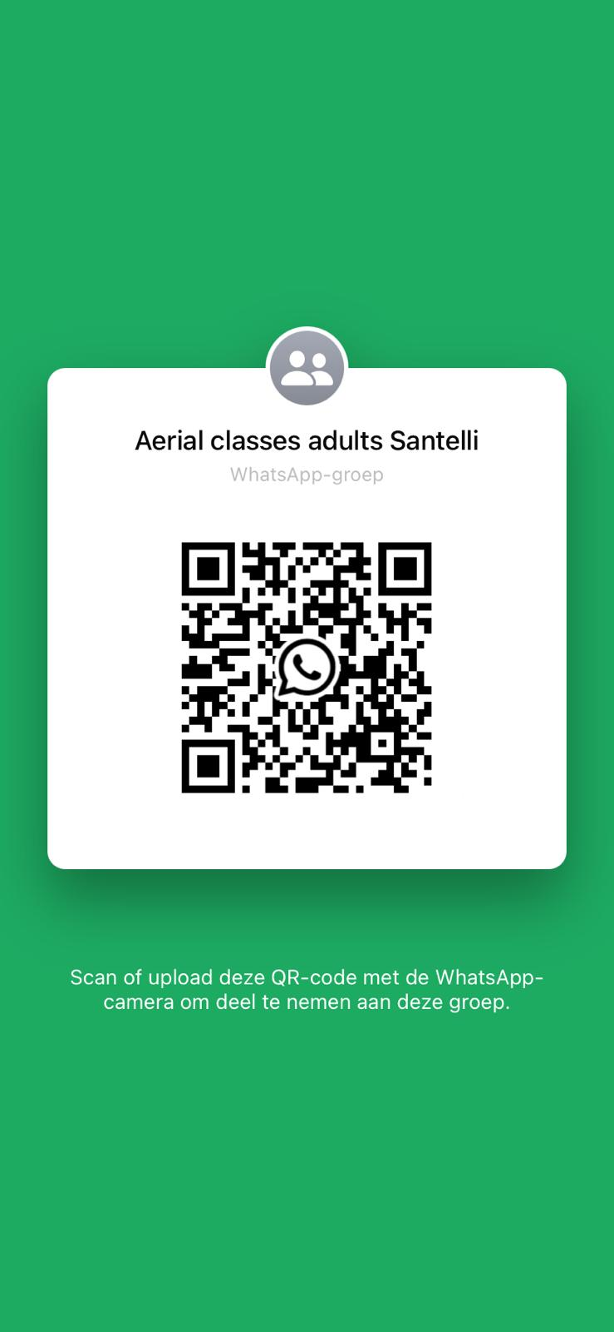

*Use whatsapp group.*

*Can't come to a class? Unsubscribe by sending a message in the WhatsApp group.*

*If you missed a lesson, you can respond to the cancellation to take over this spot.*

**Subscription form adults**

Date of subscription ………………………………………………………………………………………………..

Name + surname ……………………………………………………………………………………………………..

Date of birth …………………………………………………………………………………………………………….

Street address ………………………………………………………………………………………………………….

Zipcode + City …………………………………………………………………………………………………………..

Phone and/or Cellphone number ……………………………………………………………………………..

IBAN number (bank account number)………………………………………………………………………

Account holder …………………………………………………………………………………………………………

Email address ……………………………………………………………………………………………………………

Training day(s) and time(s) ………………………………………………………………………………………..

I am a student / I am not a student Students: Please provide a copy of your student card or come by the office to show us your student card

**Footage**

We like to keep everybody updated via our website and Social Media, and this includes posting foto’s and video’s. Here you can let us know if you object by striking out what is not applicable:

I **do / do not** object to Santelli posting photos and videos in which I appear.

Photos are always taken in consulation and are only ever used for promotional purposes.

By signing this form you give **Circus Santelli** permission to send automatic collection requests to your bank to periodically transfer your membership fee from your account to Santelli in the way specified by **Circus Santelli.**

If you disagree with a bank transfer, you can have this reversed. Contact your bank within 8 weeks after the bank transfer. Aks your bank for the terms. If you absolutely refuse to pay per automatic collection, please send an email to **info@santelli** to make an appointment to discuss cash payment.

***Training sessions, rehearsals, workshops, lessons, shows, etc. are attended at your own risk!***

Date and place Signature

**……………………………………….. …………………………………………**

***Note: cancelling your membership has to be done before* *the end of December, the end of March, or the start of Juli. The membership fee is calculated over 3 periods per school year and are debited from your bank account at the end of October, the end of January, and the end of April.***